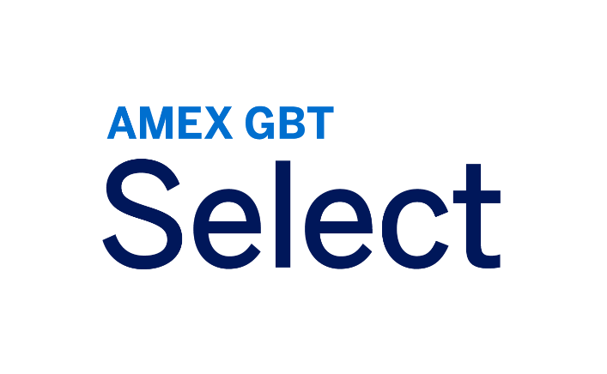

Technical Specifications

GBT Digital Products: Amex GBT Account and Amex GBT Mobile App

Table of Contents

Introduction 2

Device, Web Browser, & OS Compatibility 3

GBT Account 3

GBT Mobile app 4

GBT Mobile app supported version 4

OS Supported versions 4

Hardware requirements 4

Browser requirements 4

Mobile Device Management (MDM) 5

Domain Safelisting 6

Email domain checklist 6

Chat function 7

Languages 8

Architecture Flow 9

FAQs 10

Version History 11

Introduction

This document describes technical requirements, so your travelers can take advantage of all the features and functionality your American Express Global Business Travel (Amex GBT) Account and Amex GBT Mobile app offers.

Device, Web Browser, & OS Compatibility

GBT Account

GBT Account is built to the latest web standards to provide visitors with a seamless experience. The site is optimized to work with the latest versions and responsive design based on device. Microsoft Internet Explorer and Microsoft Edge (non-Chromium) browsers are no longer supported. Supported browsers are:

|  |  |  |  |  |  |  |
| --- | --- | --- | --- | --- | --- | --- |
| **PLATFORMS** | **APPLE SAFARI (LATEST VERSION)** | | **GOOGLE CHROME (LATEST VERSION)** | **MICROSOFT EDGE (CHROMIUM – LATEST VERSION)** | **MOZILLA FIREFOX (LATEST VERSION)** | |
| * **DESKTOP** | | | | | | |
| Apple Mac OS | • | • | |  | | • |
| Microsoft Windows |  | • | | • | | • |
| * **MOBILE DEVICE – PHONE AND TABLET\*** | | | | | | |
| Android |  | • | |  | |  |
| iOS | • |  | |  | |  |

*Not available for Admin capability

GBT Mobile app

# GBT Mobile app supported version

Only the latest version of the mobile application is supported.

# OS Supported versions

The app actively supports the **last three versions of iOS** and the **last six versions of Android OS**. For example, as of this writing:

* Apple: the latest iOS available is version 18 and GBT app supports version 16 and newer.
* Android: the latest Android OS available is version 15 and GBT app supports version 10 and newer.

# Hardware requirements

* All mobile devices with minimum OS supported (see above)
* The GBT Mobile app is not optimized for tablets
* Degraded experience of the GBT Mobile app (ex: no notification) if no Google service available on the device or in any country where these Google services would be restricted on locally purchased devices (ex: Huawei devices).

# Browser requirements

The login screens for the GBT Mobile app use the system browser, which has specific requirements.

## iOS

* Only Safari is supported.[1]
* If customer has SSO set up, then the customer must allow their identity provider (IdP) to work with Safari so their users are not blocked from authenticating into the app.

## Android

* All browsers are supported.
* If customer has SSO set up and their IdP requires a specific browser, then individual users must have that browser set as their default browser so their company’s IdP does not block them from entering the GBT app.

# Mobile Device Management (MDM)

Customers who use MDM, please note the following:

* Authorize the GBT app in MDM so your users are not blocked access.
* GBT app is compatible with MDMs but does not integrate with MDM SDKs today, so please set your MDM policies accordingly.

## Pre-populating your users’ email in the login screen

For customers managing GBT app via MDM, we recommend setting the ‘email’ key/field in MDM to automatically populate user email addresses in the login screen:

* key name= email (all lower case)
* expected value = user email address

## VPN

Customers with a VPN must safelist the domains listed in the “Email domain checklist” section below.

Domain Safelisting

When travelers register for their GBT account and/or the Amex GBT Mobile app, GBT sends a registration email to the user. The email contains the activation code (link) to verify the user’s email address and complete the registration process or service terms.

Emails are sent from: donotreply@notifications.amexgbt.com. The following email address must be added to traveler’s browser trusted site settings: [noreplyemail@amexgbt.com](mailto:noreplyemail@amexgbt.com), [noreply@access.amexgbt.com](mailto:noreply@access.amexgbt.com)

Email domain checklist

GBT encourages clients to rely on SPF, DKIM, and DMARC techniques to validate incoming emails claiming to have originated at GBT are legitimately from GBT.

GBT does not endorse safelisting email domains given it increases risk of phishing attacks. Some clients choose to also safelist email domains. If you choose to safelist email domains, here’s the list to include:

* Add the web domain “@notifications.amexgbt.com” to the browser trusted site settings, proxy and content inspection safelists.
* Ensure email domain “@notifications.amexgbt.com” is not blocked or marked as SPAM.
* Ensure email domain “noreplyemail@amexgbt.com” is not blocked or marked as SPAM.
* Ensure email domain “noreply@access.amexgbt.com” is not blocked or marked as SPAM.

**Other domains to safelist checklist**

The following domains (recommended with [*.] to support all subsites) should also be safelisted. These should include provisions for messaging-based communications:

*[*.]*access.amexgbt.com

*[*.]*global.amexgbt.com

*[*.]*digital.amexgbt.com

*[*.]*amexgbt.com

*[*.]*okta.com

*[*.*]oktacdn.com

*[*.]*okta-emea.com

*[*.]*mykds.com

*[*.]*amplitude.com

*[*.]*mytrips.amexgbt.com

[*.]static.lightning.force.com

[*.]cdn.amexgbt.com

[*.]gbtcdnstorage.blob.core.windows.net

[*.]service.force.com

[*.]salesforceliveagent.com

[*.]zscalertwo.net

Please note that the above list is subject to updates and any new domain will have to be supported by the client.

For non-SSO users using GBT Mobile app: When travelers register for the Amex GBT Mobile app, GBT sends a registration email to the user. The email contains the activation code (link) to verify the user’s email address and complete the registration process or service terms.

Emails are sent from: **donotreply@notifications.amexgbt.com**. The following email address must be added to traveler’s browser trusted site settings: **noreplyemail@amexgbt.com**, [**noreply@access.amexgbt.com**](mailto:noreply@access.amexgbt.com)

Email domain checklist:

* Add the web domain “@notifications.amexgbt.com” to the browser trusted site settings, proxy and content inspection safelists
* Ensure email domain “@notifications.amexgbt.com” is not blocked or marked as SPAM
* Ensure email domain “noreplyemail@amexgbt.com” is not blocked or marked as SPAM
* Ensure email domain “noreply@access.amexgbt.com” is not blocked or marked as SPAM

In addition, enable each of these domains to include 3rd party allowance for cookies.

Chat function

If the chat function popup loads and an error occurs or if the chat function does not appear, the issue may reside outside the American Express GBT network. Use the following steps to troubleshoot:

1. Close all browser windows, then open one browser tab to open History, clear all cookies, then try again.
2. Open browser console (or press F12) and check if any URL is getting blocked/aborted by proxy. Normally a blocked URL can be identified with “403 Forbidden” status code in browser console, allow or safelist the URL.
3. If an extension is manually installed by a user, check if the extension installed within the browser (eg. popup blocker) is blocking chat from loading. Find the extension that is blocking the popups and disable accordingly in browser settings.
4. If popups are being blocked within the browser, work with your IT to ensure company enforced guidelines include enabling popups for GBT Account. To verify, refer to: <https://support.google.com/chrome/answer/95472?hl=en&co=GENIE.Platform%3DDesktop>
5. Try logging into GBT Account using a different network to and confirm if chat is visible. If chat loads for the same user outside of the network, chat is being blocked by client network.

Languages

GBT Account and the Amex GBT Mobile app support the fourteen languages below. If a traveler has their browser or OS set to an unsupported language, GBT Account and GBT Mobile app default to English.

|  |  |
| --- | --- |
| **LANGUAGES** | |
| * Czech |
| * Danish |
| * Dutch |
| * English |
| * Finnish |
| * French |
| * German |
| * Hungarian |
| * Italian |
| * Japanese |
| * Norwegian |
| * Polish |
| * Portuguese |
| * Spanish |
| * Swedish |

Architecture Flow

Below is an overview of the technical interactions in the GBT Account and Amex GBT Mobile app solution:

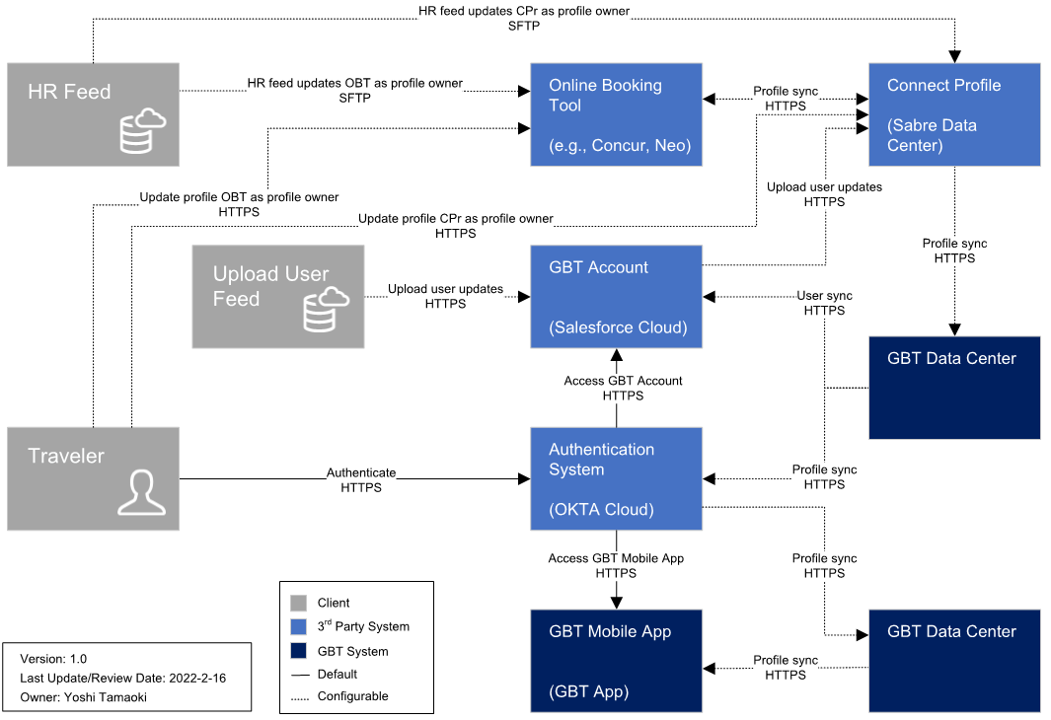

FAQs

1. Do we support MFA for users accessing product with username and password?

Yes, AMEX GBT uses email validation during initial authentication and when users try to access product from a different IP address, device, or browser.  Today all user validation is done via email.

1. Do we support MFA for SSO users?

MFA rules are determined and managed by client’s authentication configuration in this scenario.  AMEX GBT connects to the client’s IDP for user authentication on access and trusts authentication performed by client.

1. Can we support different MFA or user authentication settings for a client?

AMEX GBT only supports standard configurations for all clients today on supported browsers.

Version History

|  |  |  |
| --- | --- | --- |
| **Version** | **Publish Date** | **Summary of Changes** |
| 1.0 | Aug 08 2019 | Initial document |
| 2.0 | Aug 27 2019 | Updates to email domain checklist |
| 2.1 | Oct 08 2019 | For IE 11 added * and footnote that it is not available for Admin Capabilities |
| 2.2 | Oct 01 2020 | Updated branding  Added Architecture diagram  Added Languages supported |
| 2.3 | Feb 28 2022 | Updated arch. flow diagram and added version history page. |
| 2.4 | Apr 1 2022 | Expanded reference to browser cookies to all browsers. |
| 2.5 | Apr 21 2022 | Added safelist links |
| 2.6 | May 24 2022 | Added FAQs section |
| 2.7 | May 25 2022 | Added Personalization |
| 2.8 | June 3 2022 | Added Amex GBT Mobile App  Removed Personalization  Fixed typo to @notifications.amexgbt.com |
| 2.9 | August 8, 2022 | Updated IOS support to last three versions |
| 3.0 | August 25, 2022 | Added Chat function section |
| 3.1 | February 2, 2023 | Added chat and additional safelist domains |
| 3.2 | February 23, 2023 | Added email domain instruction |
| 3.3 | October 31, 2023 | Rebranded and removed liveperson from domains to safelist |
| 3.4 | January 03, 2025 | Added zscaler to the safelist checklist  Created a section dedicated to GBT Mobile and added Browser and MDM related information  Changed GBT Portal into GBT Account  Added information to the “Email domain checklist” section  Made some layout changes |

1. Additional browsers are planned to be supported in future.